REGISTRATION AND PREQUALIFICATION OF SUPPLIERS USER GUIDE
Introduction
This is the process of screening for potential contractors, vendors, or suppliers. It is based on experience, managerial ability, financial ability, reputation, as well as work history.
Before onboarding any merchant, assessing them for the quality of their product, time to supply, pricing, network, and reliability is mandatory.
Steps

Access the Tender Portal

  - Navigate to the tender portal; https://tenders.ndma.go.ke

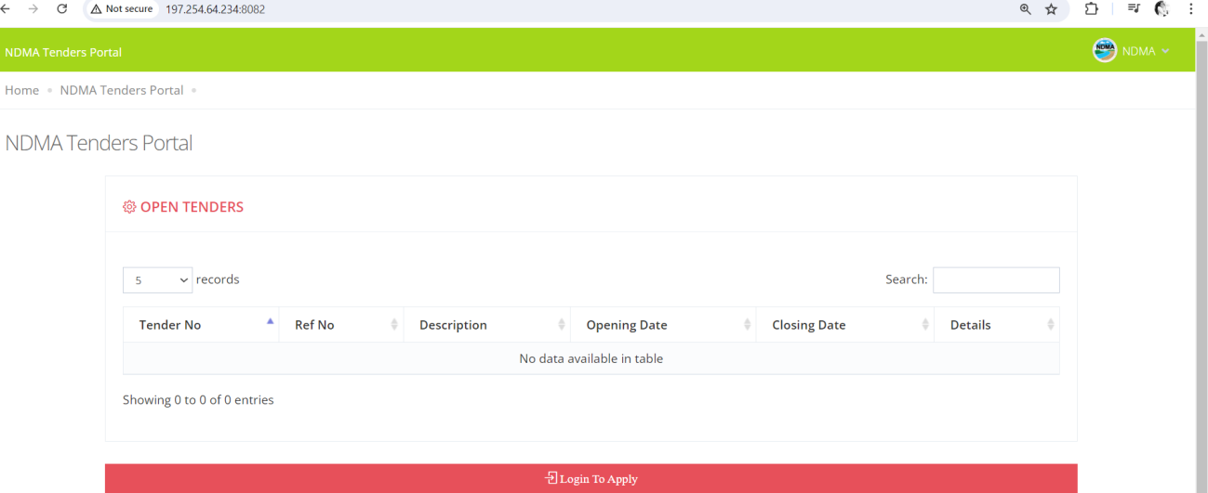
  - The following screen will be displayed:

Log In to Apply

  - Click on "Log in to Apply".

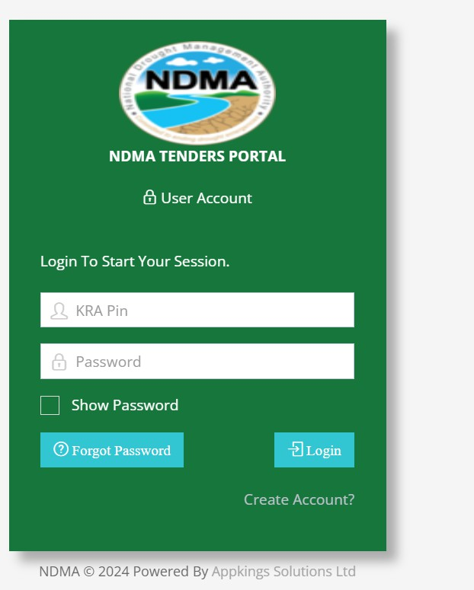

Create an Account
  - If you already have a supplier account, log in using your KRA PIN and password.
  - If you are a first-time user, click on "Create Account". The following pop-up window will appear:
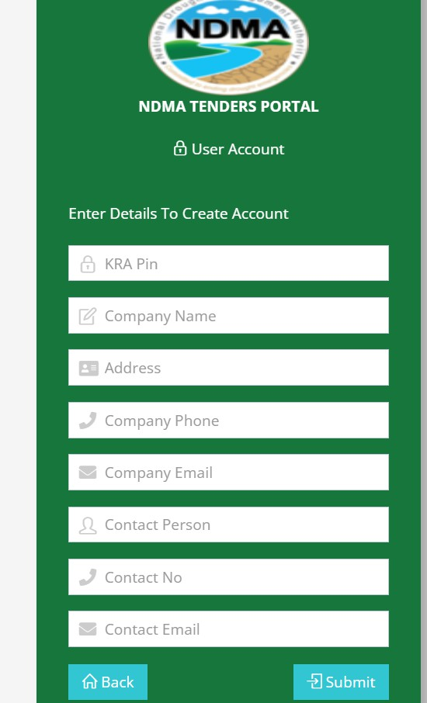

Enter Account Details

  - Fill in the required details to create an account.
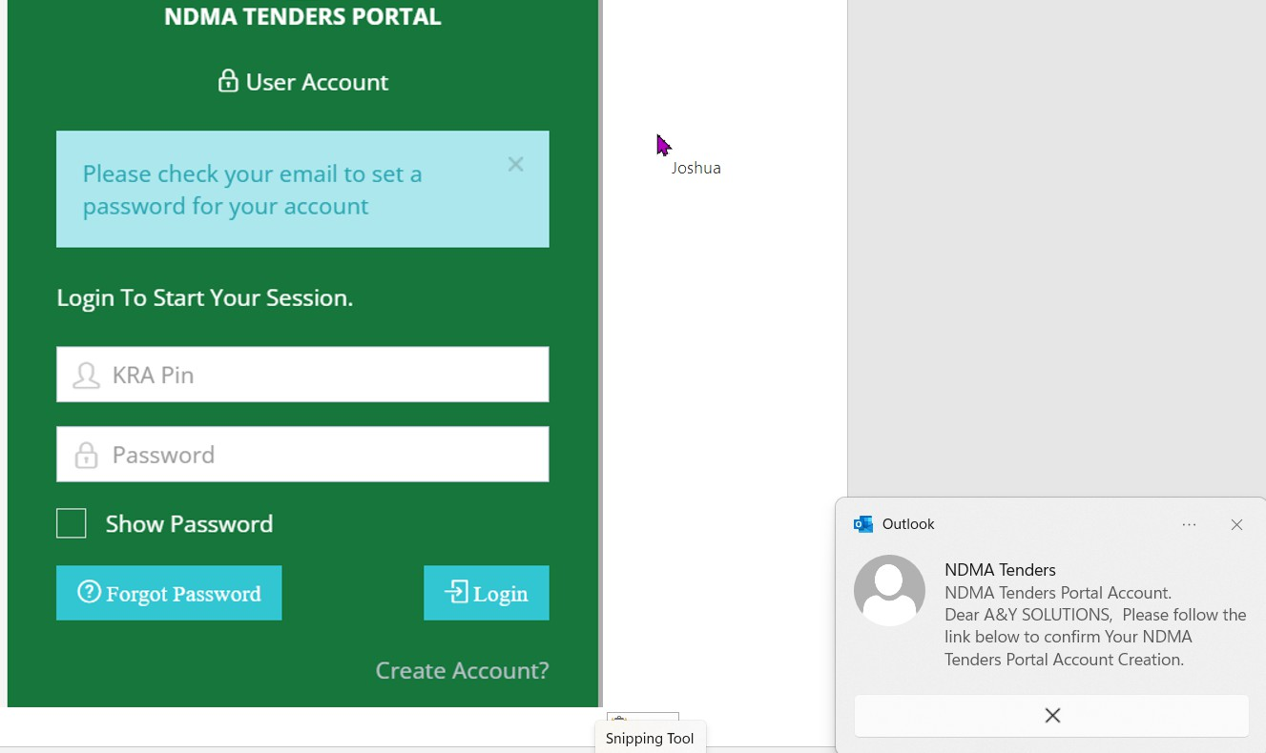
  - Click "Submit" upon completion.

Email Notification

  - You will receive an email notification with instructions to reset your account password.

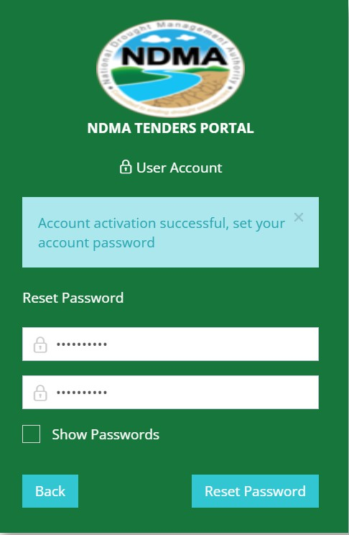

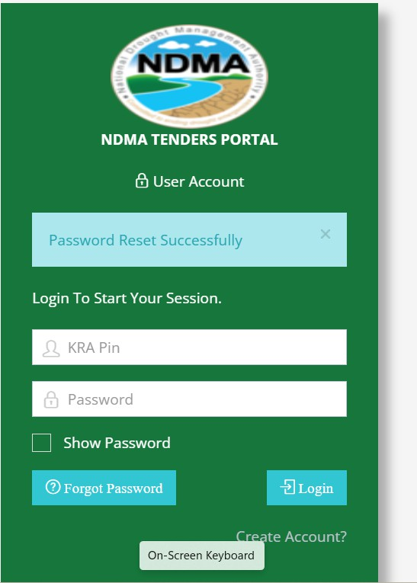

Log In to Register

  - Using your KRA PIN as the username and the reset password, log in to register and apply for prequalification.
  - Enter the OTP code sent to your email to log in.

Enter the OTP Code sent to your email to log in
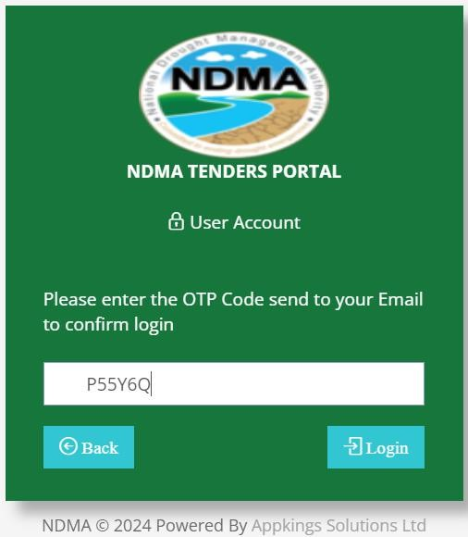

Dashboard

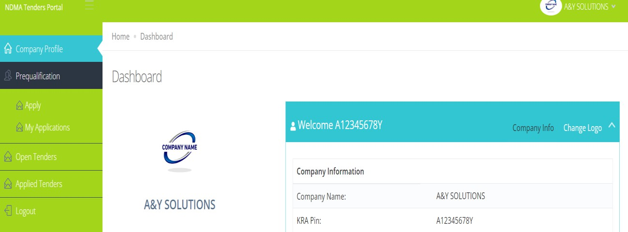
  - Upon logging in, the dashboard will be displayed as shown below:

Apply for Prequalification

  - Click on "Prequalification" > "Apply".
  - Attach the mandatory documentation.
  - Select the categories you are applying for.
  - Click "Submit".

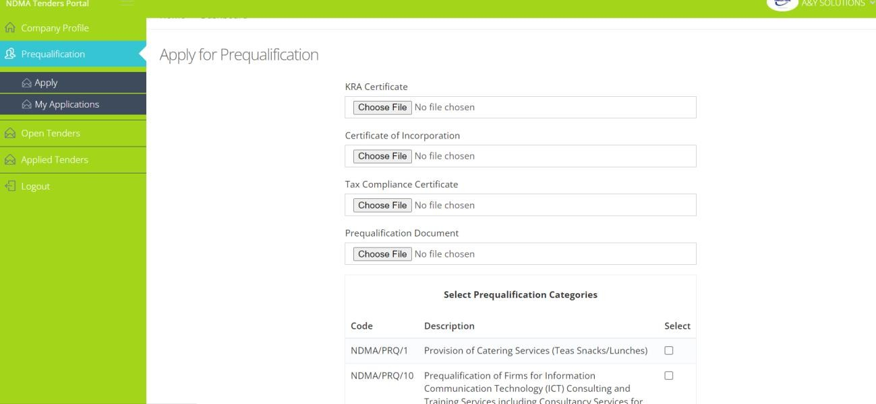

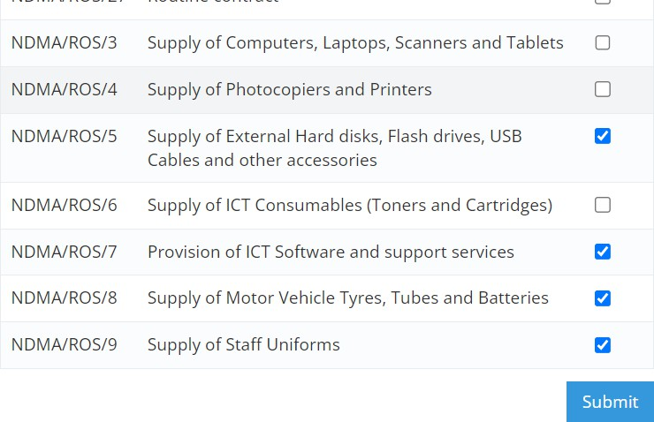

Conclusion

Following these steps will help you successfully register and prequalify as a supplier. Ensure all information provided is accurate and up-to-date to avoid any delays in the prequalification process.

